Exploration on data exchange formats

In the context of modern software architecture, particularly within microservices, the choice of data exchange formats plays a crucial role in determining the efficiency and performance of communication between services. Therefore, understanding various data exchange formats is imperative to optimize the system's overall latency and responsiveness.

JSON (JavaScript Object Notation):

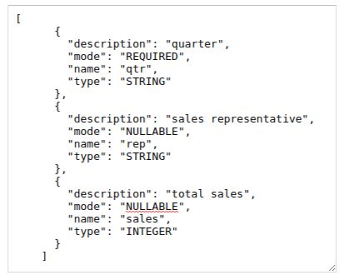

**Description**:

JSON is a lightweight data-interchange format commonly used for representing structured data. It is human-readable and easy to parse, making it popular for web APIs and microservices communication.

**Strengths:**

1. Simplicity: JSON syntax is straightforward and easy to understand, facilitating rapid development and debugging.
2. Wide Support: JSON is supported by most programming languages and has become a de facto standard for data exchange on the web.

**Weaknesses**:

1. Lack of Schema: JSON does not have built-in support for defining data schemas, which can lead to ambiguity and inconsistency in data interpretation.
2. Verbosity: JSON can be verbose for complex data structures, resulting in larger payload sizes and potentially increased network latency

XML (Extensible Markup Language):

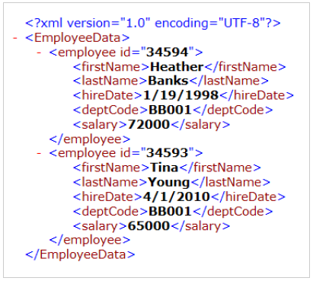

**Description**: XML is a markup language designed to store and transport data in a hierarchical format. It has been widely used for data exchange, especially in enterprise systems.

**Strengths**:

1. Flexibility: XML allows for the creation of custom data structures and supports complex document definitions through Document Type Definitions (DTD) or XML Schemas.
2. Extensibility: XML tags can be extended to accommodate evolving data requirements without breaking compatibility.

**Weaknesses**:

* 1. Verbosity: XML documents tend to be verbose due to the presence of tags, making them less efficient for transmission over the network, especially in bandwidth-constrained environments.
  2. Complexity: XML parsing and manipulation can be more complex compared to other formats like JSON, leading to potential performance overhead.

3. YAML (YAML Ain't Markup Language):  
  
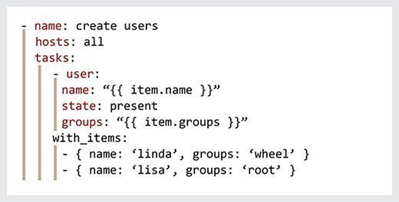

**Description**: YAML is a human-readable data serialization format that aims to strike a balance between readability and expressiveness. It is commonly used for configuration files and data exchange in various applications.

**Strengths**:

* 1. Readability: YAML's syntax is designed to be human-readable and concise, making it easy to write and understand.
  2. Expressiveness: YAML supports complex data structures, including lists, maps, and nested objects, without sacrificing readability.

**Weaknesses**:

* 1. Ambiguity: YAML's relaxed syntax rules can sometimes lead to ambiguity in data interpretation, especially in edge cases or when dealing with complex structures.
  2. Limited Support: While YAML is gaining popularity, it may not be as widely supported in all programming languages and ecosystems compared to JSON and XML.

Conclusion:

Each data exchange format has its strengths and weaknesses, and the choice depends on factors such as the nature of the data, the requirements of the system, and compatibility with existing infrastructure. In the context of microservices architecture, optimizing data exchange formats can significantly impact system performance and latency, making it essential to carefully evaluate and choose the most suitable format for the given scenario.